Glendale Primary School

Child Protection Policy

At Glendale our ethos of inclusion, equality and fairness is fundamental to the development of confident and effective learners. We aim to provide a safe, healthy and happy learning environment in which all staff demonstrate a clear commitment to the care and wellbeing of our children. Part of this commitment is the understanding of the wellbeing indicators of ‘Getting It Right for Every Child’ and the need to intervene in aspects of children’s lives beyond the school gate when we feel their treatment or standard of care falls short of what they deserve.
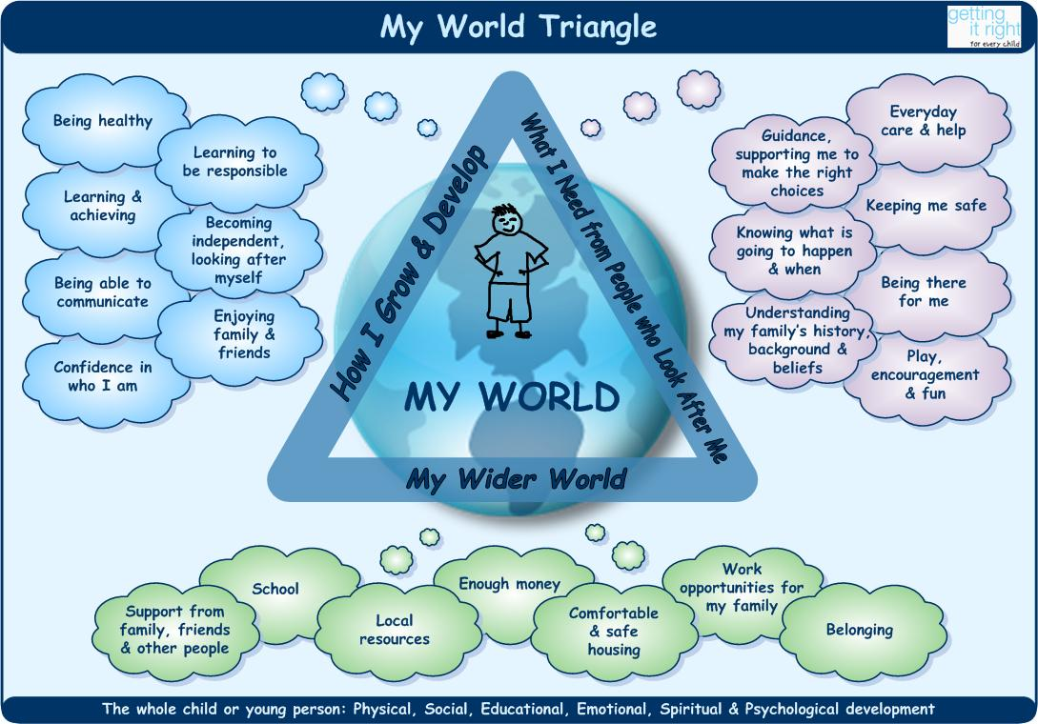

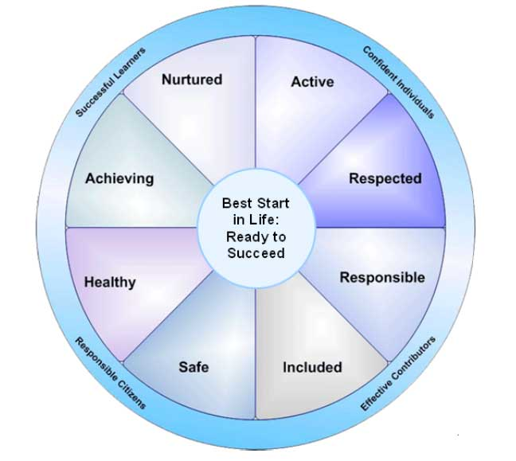

The following measures are in place to ensure the safety and wellbeing of our children:
- Daily vigilance of all staff of children’s physical and emotional wellbeing.
- Listening systems e.g. Bubbletime to enable children to access a chosen adult in school.
- Reporting by all staff to HT / DHT of any concerns, no matter how insignificant they may seem.
- Partnership working with families to offer / access support for children.
- Annual whole staff revision of MC57 and its implementation in our school.
- Effective multi-agency working by HT with partner agencies e.g. health and social work.
- HT attends CP trainings as they arise.
- HT records own and staff training.
- Maintenance of chronologies for at risk children.

Annual Whole Staff Review of MC 57 ‘Child Welfare and Safety’

The whole staff, including the janitor and clerical staff meet to re-emphasise the role that every member plays in watching and listening to the children. Although these categories are no longer used when children are placed on the Child Protection Register, they, and the new ones added, help staff to focus on the range of ways in which children can be at risk.

- Failure to thrive
- Neglect
- Physical abuse
- Sexual abuse
- Child trafficking

- Internet safety
- Cyber /mobile phone bullying
- ‘Invisible children’

Any member of staff may have a concern as a result of …
- a specific incident
- a disclosure made by a child or young person or parent/carer
- information from a third party
- adult behaviour/circumstances that may place the child or young person at risk of harm
- child/young person behaviour/circumstances that may place the child or young person at risk of harm
- a culmination of minor concerns over a period of time.

What to do if you have a concern

- Consider the wellbeing and safety of the child or young person - listen and reassure
- Don’t panic
- Don’t ignore
- Don’t agree to keep it secret
- Do not interrogate
- Don’t discuss with colleagues
- Don’t feel daft – your concern might be part of a bigger picture
- Inform the HT or DHT without delay

It is the Head Teacher’s responsibility to record and decide what action to take in the light of staff reports of concerns, and in accordance with the following outlined procedures.

