**Book Club Competition!**

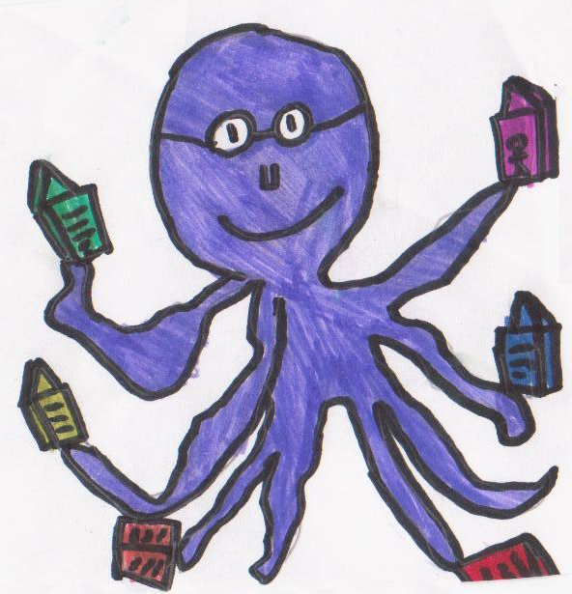

**Draw a picture of your favourite story book character. Make it big and colourful! Be enthusiastic! Think of all the fabulous story characters you could choose from! You could add some writing if you would like to.**

**What do I have to do?**

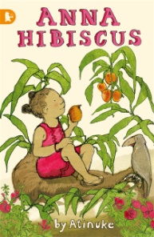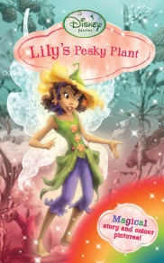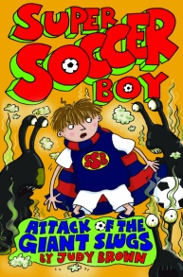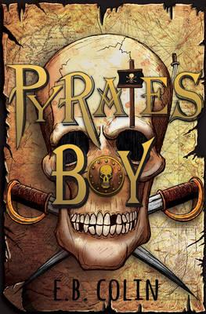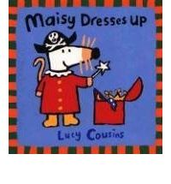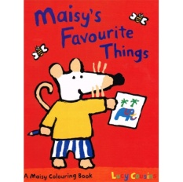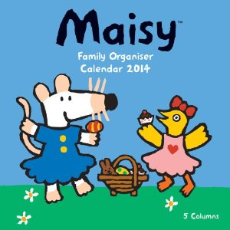

**From your teacher or from Mrs Fagan.**

Mrs Fagan.

***All entries to Mrs Fagan by Tuesday 25 February!***

**You will win brilliant books and a special surprise! There are prizes for different stages of the school – P.1-2, P.3-5 and P.6-7.**

As soon as you have it ready!

**What will I win?**

When dWhao I hand it in?

**Where will I get the paper?**