**Well Done!** [](https://www.google.co.uk/url?q=http://www.school-clipart.com/school_clipart_images/an_asian_boy_carrying_a_large_stack_of_books_0521-1005-0821-5753.html&sa=U&ei=5kyLU4bXFsisO7uXgIAH&ved=0CEQQ9QEwCzgU&usg=AFQjCNGF8o4qXtzl-6RZhub3LcBzBAhWaw)

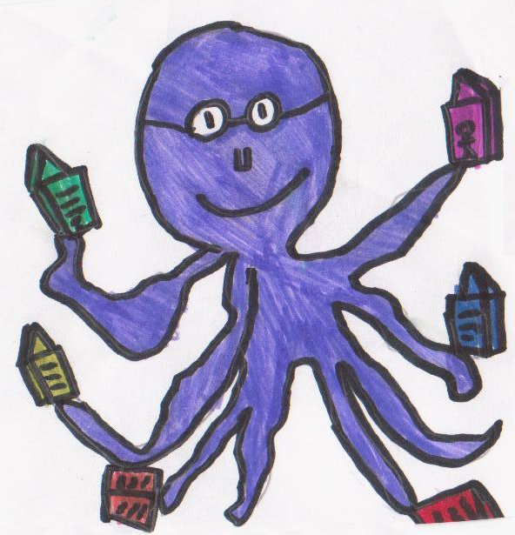

C:\Users\mf2411920\AppData\Local\Microsoft\Windows\Temporary Internet Files\Content.IE5\MG100C05\MC900155356[1].wmf

Hi Everyone!

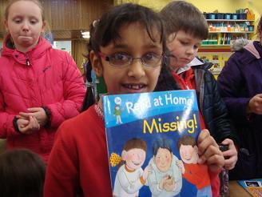What a fantastic year we have had at Book Club! It has been wonderful to see so many of you return to our Book Club and, of course, to welcome newcomers not only from P1 but from all stages of the school! You have bought a huge amount of books, with the last six months being particularly busy. More and more children have been choosing to save up for a favourite book, putting our learning from Financial Education Week into action! Lots of boys and girls made requests for new titles and where possible, we have been able to provide these books at a very reasonable price.

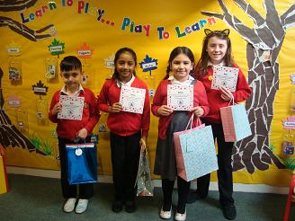Earlier in the year, we had a storybook character competition! You were very enthusiastic about the chance to draw and sketch your favourite story people. Although it was difficult to pick the top entries, we had four great winners from across the stages.

As we come to the end of this session, I just want to remind you that the final day of Book club for this session is -

Although Book Club will be closed over the Summer Holidays you can still keep reading!!!!! Have you heard of the **Summer Reading Challenge**? It is a brilliant idea to help you all to get involved with your local library, (for most of you that will be Pollokshields Library), while you are off school. It is completely free and anybody can take part! Click on the link to find out more! <www.summerreadingchallenge.org.uk>

See you all back at **Book Club** in August! Happy reading everyone!

**MONDAY 9 JUNE!**