C:\Documents and Settings\maureen fagan\Local Settings\Temporary Internet Files\Content.IE5\GHZUBU1A\MC900410717[1].wmf

**Come along and have a look at the new books for sale in our fab Book Club! All titles still only £1.50! Recycled books 50p! Remember you can save!**

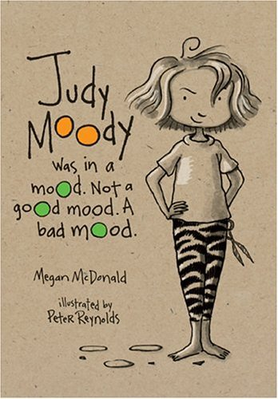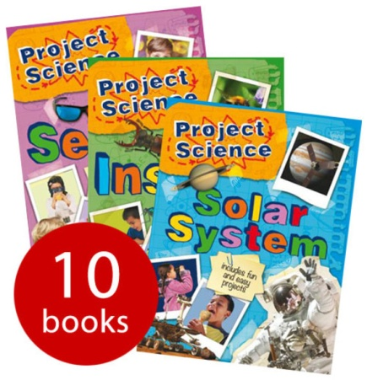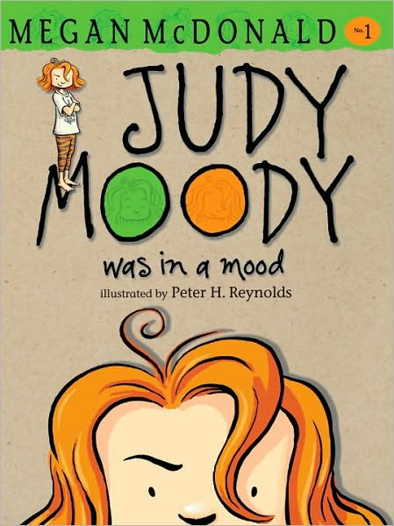C:\Documents and Settings\maureen fagan\Local Settings\Temporary Internet Files\Content.IE5\WYQR8Y3K\MC900239421[1].wmf

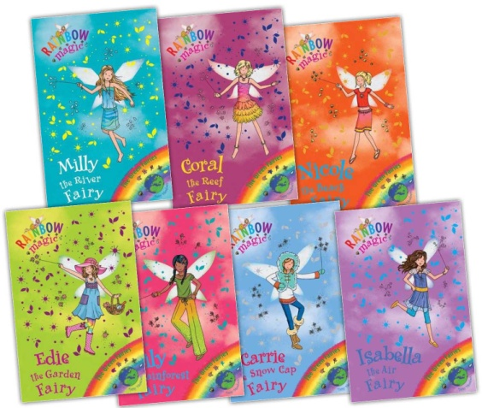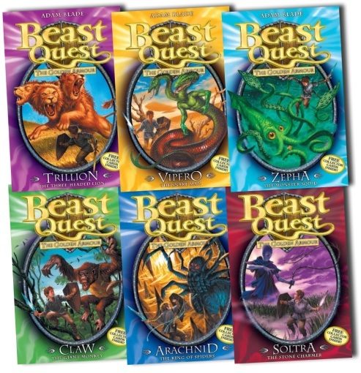

**For any special requests, please come and see Mrs Fagan!**