Glendale Primary School

Learning & Teaching Strategy

‘We know that the quality of teaching and the relationship between teacher and child or young person is critical in ensuring the effectiveness of the learning experience and we aim to champion an aspirational approach for our young people.’ Gcc

Glendale’s children come to school with widely varying pre-school experiences and abilities, and from a variety of religious, social, cultural and ethnic backgrounds. The ethos in our school encourages pupils, parents/carers and staff to recognise these differences as positive. It helps us to understand how this diversity supports our learning and teaching on equality and fairness and is fundamental to the development of confident individuals and responsible global citizens. Many aspects of school life will afford the opportunity to encourage and celebrate the use of our children’s first languages.

Placing inclusion at the heart of school life promotes positive behaviour and successful learning. Children who feel listened to and respected take valuable risks in their learning, knowing that they are supported by, rather than in competition with peers. The school’s positive behaviour approaches are consistently applied to build a shared understanding of expectations in our school community. We discuss our high expectations with our children and parents and expect our learners to be effective contributors because they feel safe, healthy and happy at school with staff who are clearly committed to them and care genuinely about their wellbeing.

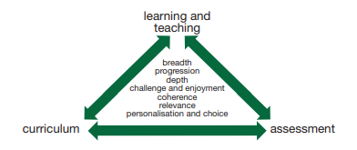
When planning for learning, staff will focus on the Experiences and Outcomes of the Curriculum for Excellence, taking into account the needs and interests of all our learners. Planning will be clear and strategic, building on children’s prior knowledge and allowing for personalisation and choice within the curriculum. Programmes will meet the needs of individual learners, and groups with differing abilities, and will aim to engage all children in active experiential and contextualised learning.

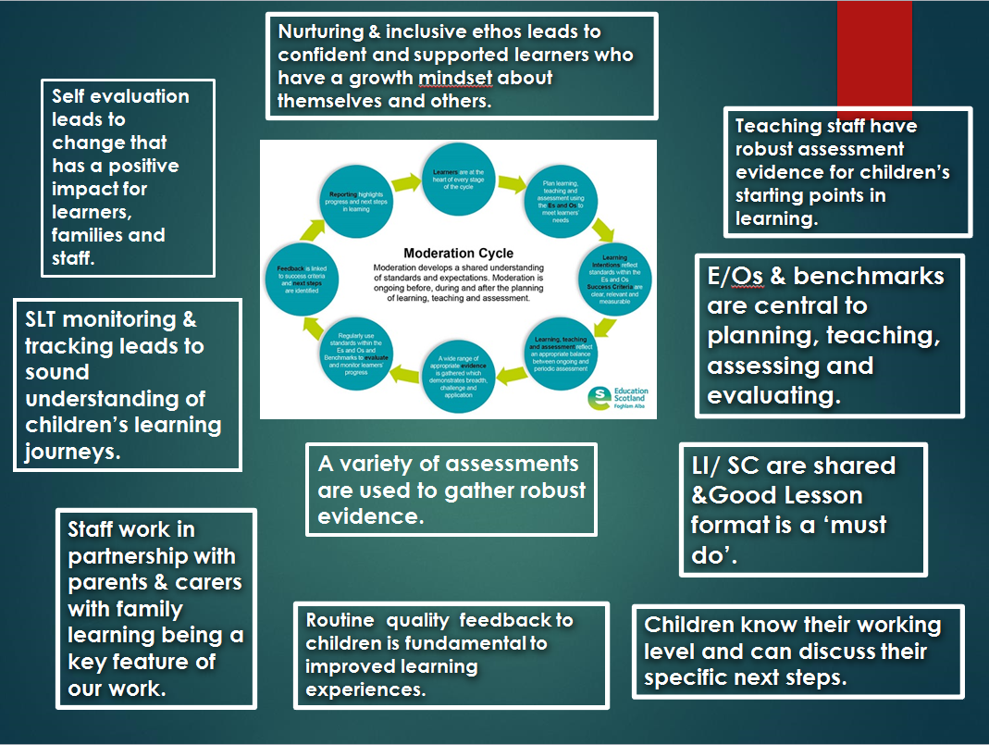
Our learning & teaching aims to interweave these processes consistently.

Learning & Teaching…what does it look like in our classrooms?

Classrooms must be tidy, with resources which are organised, accessible and meet the children’s needs. The learners should self-select resources and take responsibility for accessing and tidying.
Walls should reflect curricular areas, with children’s work displayed and celebrated. Displays should be interactive and aid learning where possible.

When planning for learning and teaching, staff use experiences and outcomes to plan learning intentions. Success criteria are increasingly created from benchmarks and are often co-constructed with learners. Planned and incidental opportunities for interdisciplinary learning should be evident. Children should know what level they are working at and what their specific next steps are to progress. Teachers should be using the Good Lesson format and a variety of assessment strategies throughout their day.

Good Lesson Format

- LI / SC
- Direct teaching
- Cognitively active and often collaborative tasks
- Reference to SC during the lesson
- Aspects of AiFL
- Plenary
If learning is Active, Collaborative and Cognitive, children will have …

Active | Collaborative | Cognitive
- been involved | - worked in a team | - asked questions
- listened to others | - shared ideas | - answered questions
- taken responsibility | - contributed | - thought of ideas
- explained to others | - taken turns | - created something new
- worked things out

Assessment procedures are covered in a separate policy.

