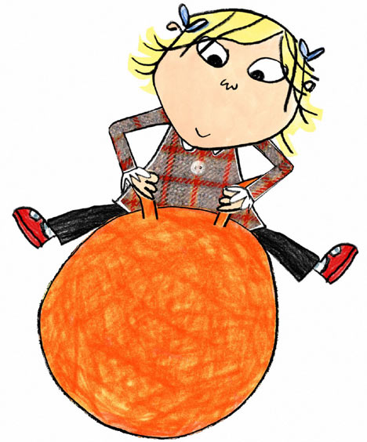

**Hey Henry! Have you heard the good news? Glendale’s Book Club is open again from Monday 20th October!**

[](http://www.homeserviceclub.com/?page_id=2338)[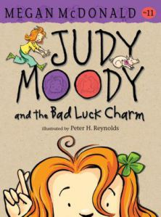](http://brodartvibe.files.wordpress.com/2012/07/judy-moody-and-the-bad-luck-charm.jpg)[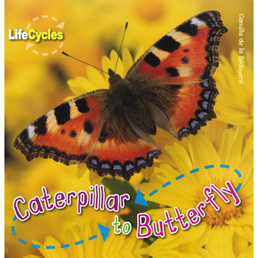](http://www.theworks.co.uk/images/9781848359109_Z.jpg)[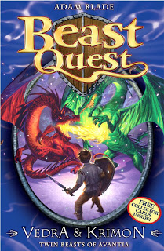](http://2.bp.blogspot.com/_PG1oBhIcPBQ/TBwwdNaHJsI/AAAAAAAAAFE/doDt5DEvw38/s1600/bq.jpg)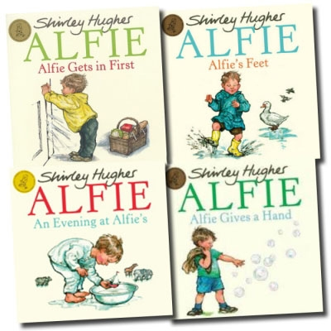[http://ecx.images-amazon.com/images/I/51QiUf-1ghL._SL75_PIsitb-sticker-arrow-st,TopRight,8,-14_OU01_.jpg](http://www.amazon.com/gp/product/0763648590/ref=pd_lpo_sbs_dp_ss_3?pf_rd_p=1944687762&pf_rd_s=lpo-top-stripe-1&pf_rd_t=201&pf_rd_i=0763648493&pf_rd_m=ATVPDKIKX0DER&pf_rd_r=1R5VYP5BZJW1Z0NPTENT)[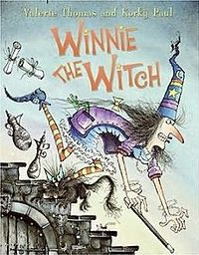](http://en.wikipedia.org/wiki/File:Winnie_the_Witch.jpg)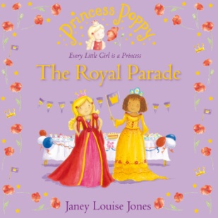[](http://www.poppysbooks.co.uk/ekmps/shops/poppysbooks/images/princess-poppy-playground-princess-705-p.jpg)**[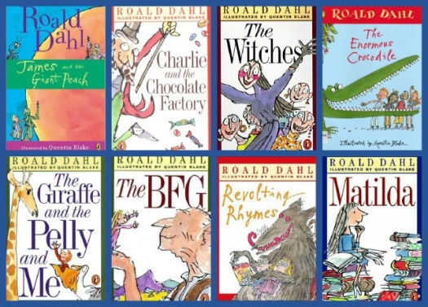](http://stmichaelscatholicprimary.co.uk/wp-content/uploads/2013/09/dahl-2.jpg)**

**Thanks to everyone who made special requests for new books for this session. I have managed to get some of your titles and will keep trying for the rest! Hope you have fun choosing books at Book Club this year! Happy reading!**

**LOTS OF RECYCLED BOOKS FOR SALE AT 50p!** **SEE YOU AT 12.30pm IN THE OPEN AREA!** **REMEMBER YOU CAN SAVE UP!**

**We’ll be there too!**

**Sure have Lola! Lots of good titles all about me! Still only £1.50! See you there!**